## **Project #6 - Pig Poster**

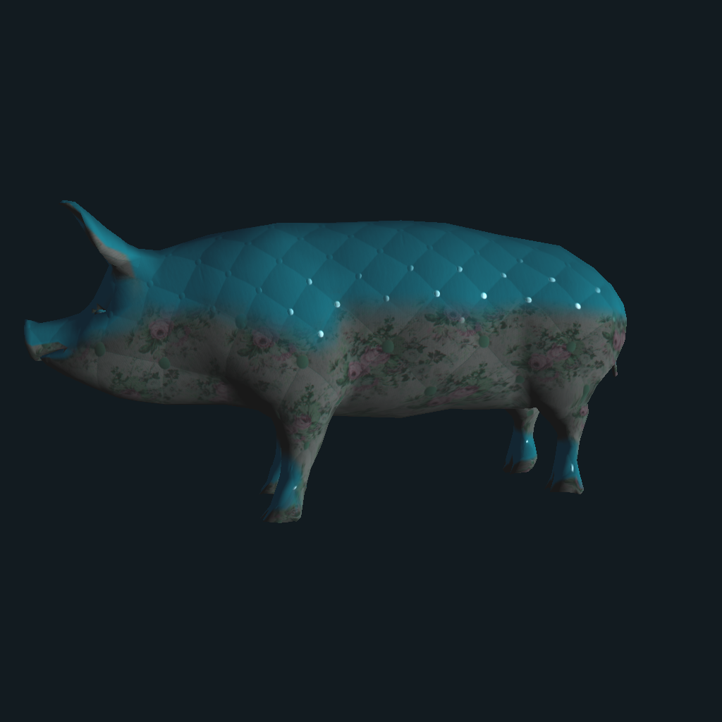

To do this assignment, I had to do some research about how to load in and use texture mapping files within the fragment shader, from there I had applied the base pig with mapped textures for its normal, its diffuse, and its specular.

I created a second method to cover the current pig with another texture mapped effect, using just the normal and the specular maps and setting the diffuse within the frag file.

Overall, I think the mapping that went into this assignment was fun, and was great practice for the final project.

Video: <https://media.oregonstate.edu/media/t/0_n3l1gnmd>